ABSTRACT

They do it using a device called an oil water separator. Its really pretty simple. Water is heavier than oil so oil will rise to the top. That's the reason you can see the oil spill on the water in the gulf right now. If you have a container with a bottom drain and you fill it with a water and oil mixture the oil will float to the top and you drain the water from the bottom.
Up to the present day a large number of significant marine oil spills had devastation consequences for the maritime and coastal environment followed by economical disasters for the local fishing industry and tourism. The risk of further oil spills is present every day.
In these operating systems of the oil recovery fleet and their operational limitations are discussed. Basically all recovery systems can be assigned to four basic working principles.

INDEX

CHAPTER  NO. | Topic | PAGE  NO.
Chapter-1 | INTRODUCTION | 07-10
Chapter-2 | OIL COLLECTOR IN SEAWATER | 11-27
 | 2.1 How to remove oil from sea water
 | 2.2 Instructions
 | 2.3 Materials used to remove oil from sea water
 | 2.4 Key words
 | 2.5 Components of oil collector
Chapter-3 | WORKING OF OIL COLLECTOR | 28-33
 | 3.1 Working of oil collector
 | 3.2 Waste oli collection systems used
 | 3.3 Collection processes
 | 3.4 Main problems found related to the waste management
 | 3.5 A new sea ways independent oil skimmer
Chapter-4 | CONCLUSIONS | 34-35
Chapter-5 | REFERANCE | 36-36

CHAPTER-1

INTRODUCTION
The waste oil collection system starts from the moment when oil becomes waste, this means after they are used. In general we are talking about oil and fat used for frying. The producers/owners of waste-oil must contact the waste-oil management company and request them a collection point. These collection points are usually metal and plastic containers at the producer's place. Depending on the producer and the quantity of waste-oil it produces, the management company supplies different types of containers:
Removing oil from seawater can be a daunting task. Oil has a lower specific gravity (0.79 to 0.84) than seawater (1.023 to 1.028) and floats on top of seawater for that reason, which makes "skimming" one of the most effective "immediate" ways to remove crude oil from seawater. Other methods have been developed, including using a dispersant to sink the oil, bringing in "oil-eating" bacteria, and simply allowing the oil to break down through natural processes.
In these operating systems of the oil recovery fleet and their operational limitations are discussed. Basically all recovery systems can be assigned to four basic working principles.
Main problems and difficulties found by the waste-oil management companies in the process and possible solutions to overcome them:
The main problems and difficulties found by the waste-oil management company in the development of the collection network are related to the refusal of many waste-oil producers (restaurants, factories, etc.) to use specific containers to keep the waste-oil in their establishments. According to the local management company's opinion, local authorities should force these establishments to contract waste-oil management services if they want to obtain their Business License. Another important barrier is the lack of specific budgets from local authorities aimed at improving the current collection network. Burgos Provincial Energy Agency will work in the improvement of the collection network during the duration of PROBIO Project. In these sense, big department stores and city councils will be contacted in order to propose them the establishment of new collection points.
With a length of 26 months, between May 2004 and February 2006, it was developed a European pilot project across the program ALTENER called " Local & Innovative Biodiesel "Place and Innovative Biodiesel ", with the participation of public organizations and companies from seven countries of the European Union coordinated by the Regional Entity of Energy from Castellany Leon,
(EREN - Spain). The principal aim of the project was the development of specific actions for the collection of vegetable used oils on domestic level, promoting the biodiesel production on regional level, a well as the analysis of the biodiesel characteristics obtained from several kinds of vegetable oil, in accordance with the conditions of each region, as well as to establish a recommendations set on more suitable mixtures of different sorts of oils and fats, which assure a biodiesel production on high quality, helping to reach the fixing aim by the European Directive 2003/30, relative to the promotion of biofuels use in transport, fixing in 5,75 % the consumption minimal percentage of fuels for the year 2010.
Developed pilot experience in Castilla y Leon was carried out in ten localities, in the province of Avila it counted on the County Council of Avila collaboration, across the Energy Agency of the Province of Avila, as well as on the Town hall of the city. Between the selected localities there were Avila City, Ar6valo, Casillas, Navaluenga, Piedralaves and Sotillo de la Adrada.
The collection systems that were in use in the project were:
- Mobile units based on a draft programme
- Fixed Points: urban containers with 600L. of capacity
- Collection in schools with small containers
- Collection in neighbours' communities with small containers

The project was reinforced by a diffusion campaign by means of divulgate chats, information at the foot of street, delivering door-to-door, mass media, etc.

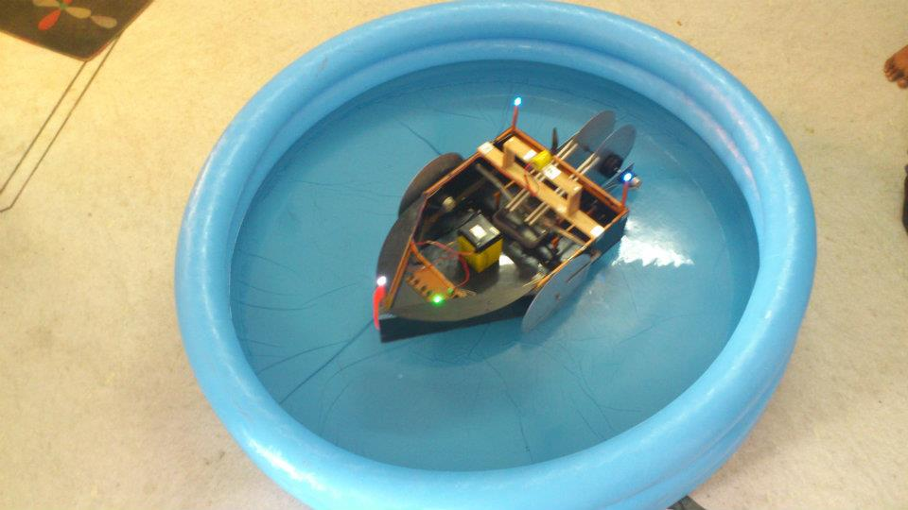
[FIG.1.1]

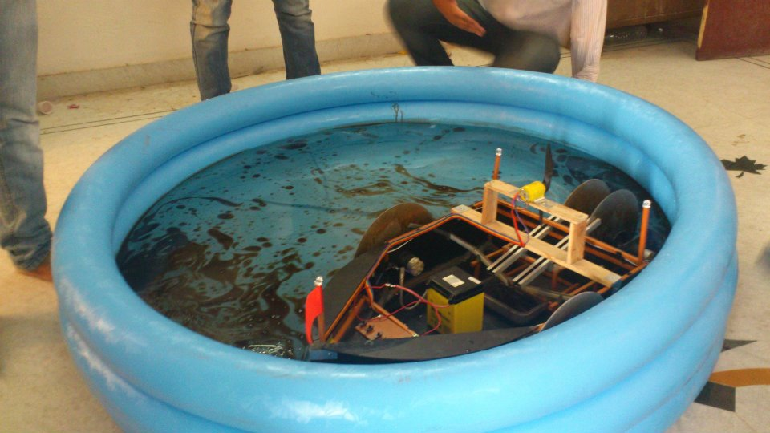
[FIG 1.2]

CHAPTER-2 OIL COLLECTOR IN SEA WATRE:

They do it using a device called an oil water separator. Its really pretty simple. Water is heavier than oil so oil will rise to the top. That's the reason you can see the oil spill on the water in the gulf right now. If you have a container with a bottom drain and you fill it with a water and oil mixture the oil will float to the top and you drain the water from the bottom.
Up to the present day a large number of significant marine oil spills had devastation consequences for the maritime and coastal environment followed by economical disasters for the local fishing industry and tourism. The risk of further oil spills is present every day.
In this operating systems of the oil recovery fleet and their operational limitations are discussed. Basically all recovery systems can be assigned to four basic working principle.

2.1 How to Remove Oil from Sea Water:
Removing oil from seawater can be a daunting task. Oil has a lower specific gravity (0.79 to 0.84) than seawater (1.023 to 1.028) and floats on top of seawater for that reason, which makes "skimming" one of the most effective "immediate" ways to remove crude oil from seawater. Other methods have been developed, including using a dispersant to sink the oil, bringing in "oil-eating" bacteria, and simply allowing the oil to break down through natural processes.

2.2 Instructions:

1. One method is to do absolutely nothing. The effects of solar radiation, wind, and current will disperse the oil, and eventually it will evaporate. The heavier parts that don't evaporate will sink. This method only works, though, when land areas, such as beaches, aren't in danger of being covered by an oil slick, and it maximizes the dangers to fish and wildlife exposed to the oil spill.
2. Using dispersants to sink an oil spill is frowned upon in U.S. waters. Dispersants act in the same way as a popular dishwashing liquid. They effectively eliminate the surface tension that prevents water and crude oil from mixing and break the oil up. The oil is then diluted by the water and "naturally" eroded.
3. Introducing "oil-eating" bacteria and nutrients, such as nitrogen and phosphorus, into a spill will speed up the natural degradation of the oil. Special bacteria can break the oil down into innocuous substances such as CO2 and fatty acids through a process called bio-degradation. Nutrients make the oil more " palatable" for the bacteria, so that they ingest more oil.
4. Setting fire to an oil slick removes the oil by converting the form of its potential energy to heat and light. This approach leaves behind a heavy carbon residue and is suitable only for use on the open ocean.
5. Oil slicks can also be removed with containment booms. After the slick is contained, a vessel equipped with skimming equipment can remove it. The skimmer is used to "vacuum" the oil slick-which is only a few millimeters deep- into a tank aboard the skimmer vessel. Skimmers don't work well in high winds or seas.

2.3 Materials Used to Remove Oil From Seawater:
Oil has become an indispensable part of modern life, providing us with such everyday essentials as the gas for the cars we drive and fabric for the clothes we wear (even polyester is a petrochemical material). However, as the demand for petroleum-related products rises, so does deep sea drilling, crude oil sea-borne transportation and other activities that can and do sometimes result in oil spills. Fortunately, people have invented ways to limit the damage made by such spills to human health and the environment; and substances that help remove oil from sea water are among the chief oil response techniques.
2.3.1Dispersing Agents:
The first line of defense against oil spills is dispersing agents or dispersants- chemicals that help break crude oil into small droplets that are then broken down naturally by sea waves and currents. Because light and medium weight oils disperse much better than heavy crude oils, oil cleanup teams apply dispersing agents during the first stages of the cleanup efforts, before the light materials in the spilled oil have evaporated.
2.3.2 Gelling Agents:
Gelling agents, or solidifiers, are chemicals that transform oil into rubber like solids that the cleanup teams can then much more easily remove from the water using nets and skimmers (a skimmer is a device used for collecting spilled oil from the water's surface). However, because you need as much as three gallons of the gelling agents to solidify one gallon of the gelling agents to solidify one gallon of oil, this material is largely impractical for large spills where millions of gallons of oil need to be removed from the water.

2.3.3 Biological Agents:
Biological agents are widely used to remove oil from sea water. Biological agents are organisms or chemicals that increase the rate of natural biodegradation, a process that "recycles" the oil in a natural fashion with the help of microorganisms such as bacteria, yeast and fungi. If left alone, oil degrades very slowly, often in a matter of years, and until it is fully decomposed, it can damage the delicate marine ecosystems. Biological agents help biodegradation processes go faster. The primary cleanup techniques that employ biological agents are fertilization- providing the microorganisms capable of biodegradation with the nutrients to make them grow faster (e.g., phosphorus and nitrogen) and seeding - adding such microorganisms to the contaminated environment.

2.4 KEY WORDS
- Oil spill
- Oil combating fleet
- Oil recovery vessel
- Oil skimming systems
- Wave absorbers

2.5 COMPONENTS OF OIL COLLECTOR:
- BATTERY: 12V/2.5AH
- MOTOR: 12V/10RPM
- MOTOR: 12V/22000RPM
- LED: WHITE (1nos)
- LED: BLUE (2nos)
- ALUMINIUM PLATE: dia- 11.5 (4 plate)
- SHAFT
- SHAFT JONT
- ACRELIC (3mm) AND ALUMINIUME MATERIAL
- POPULER FAN
- ELECTRIC SWITCH
- RESISTENCE
- MOTOR STAND

PLATE

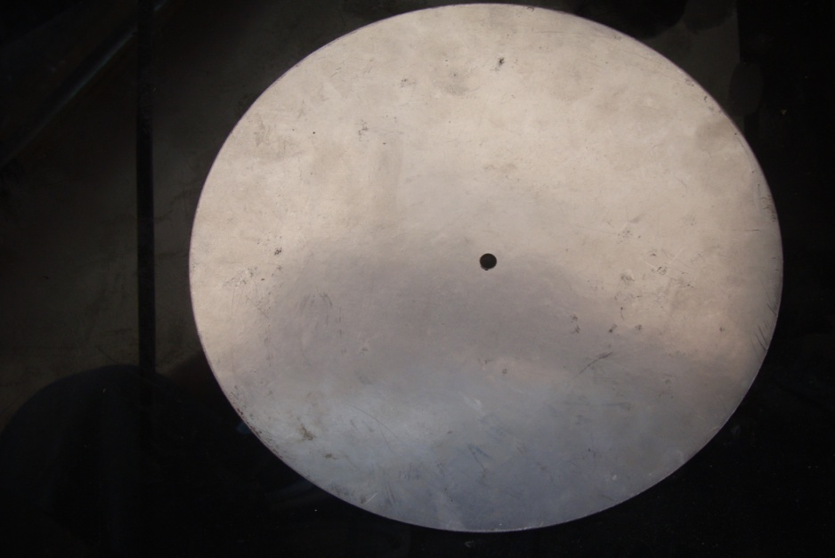

Description

Size : 10”
Thickness : 1mm.
Hole dia : 4mm.
Material used :aluminium.

BODY

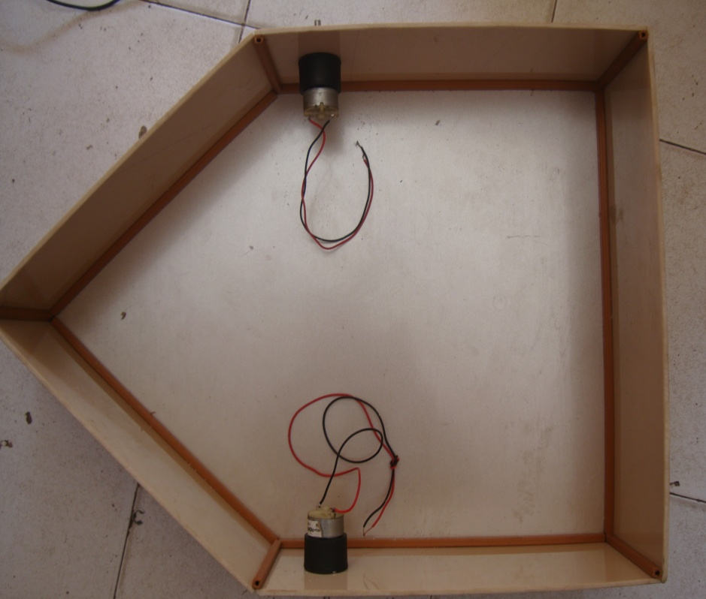

Description

Size : length : 57cm .
Width : 41 cm.
Height : 13.50 cm.
Material used: acraylic.

MOTOR

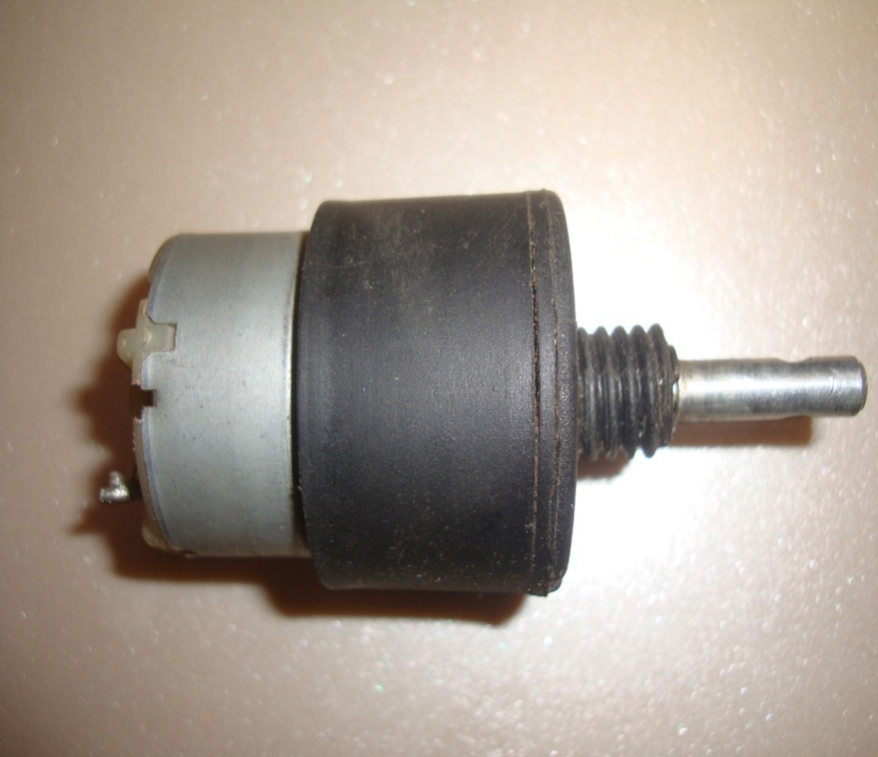

Description

Rpm : 13.
Volt : 12v.
Shaft : 6mm.

ALUMINIUM STRIP

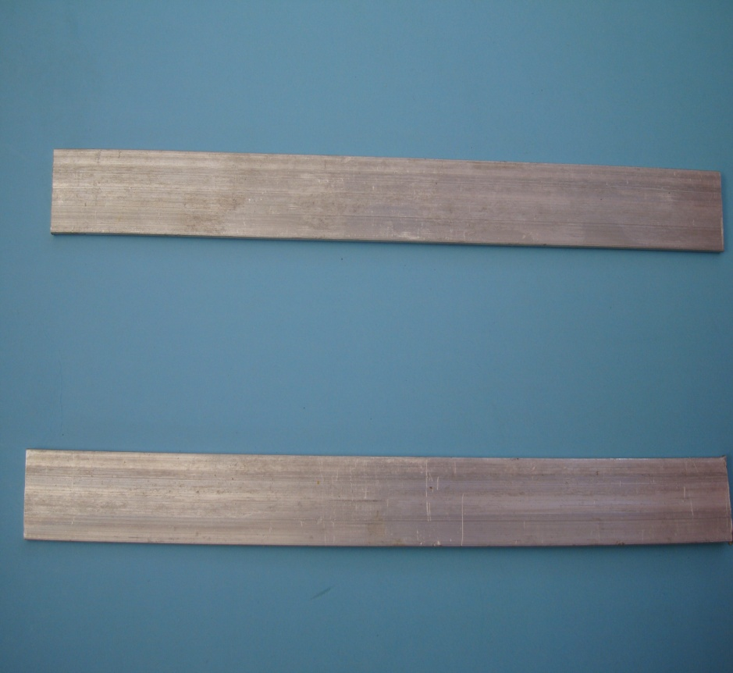

Description

Size : length : 20 cm
Thickness : 4mm
Width : 25mm
Material used :aluminium.

OVER CRAFT

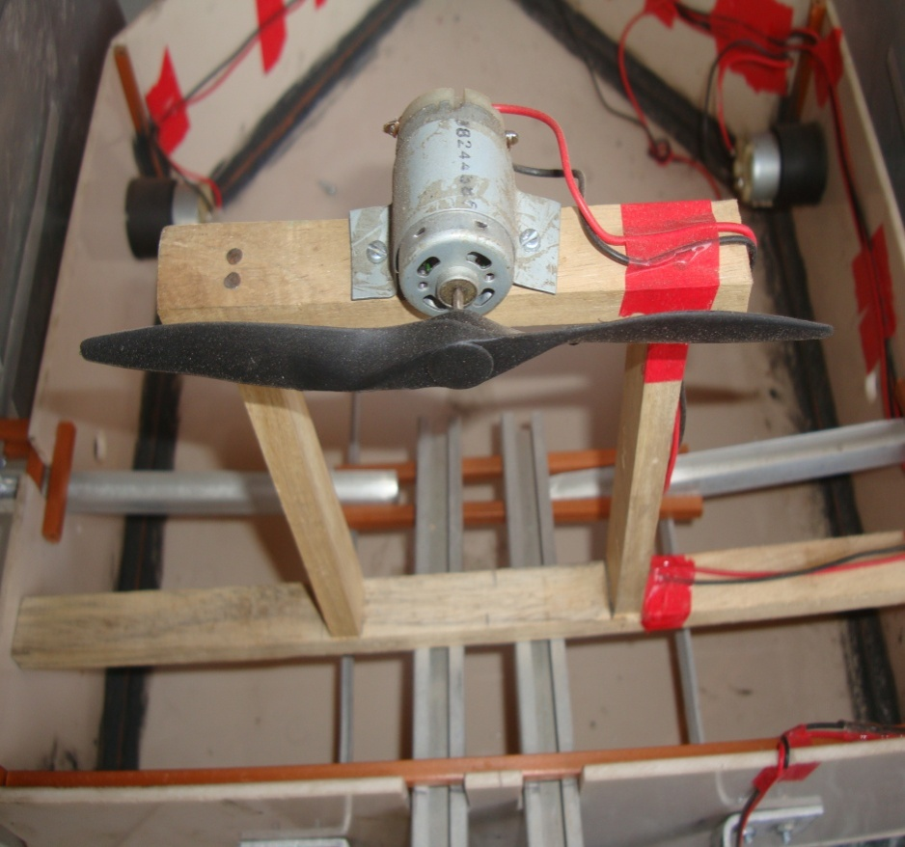

L SHAPE ALUMINIUM STRIP

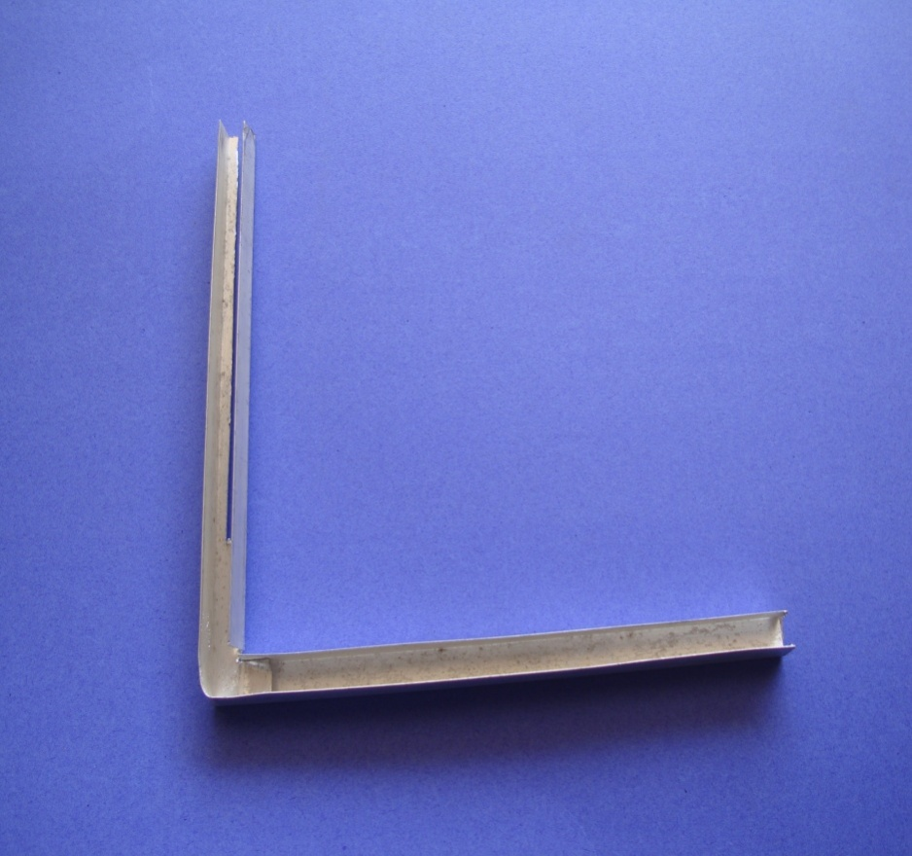

Description

Size : length : 20cm*18cm
Width : 1cm
Angle : 90 degree
Material used :aluminium.

PLASTIC STRIP

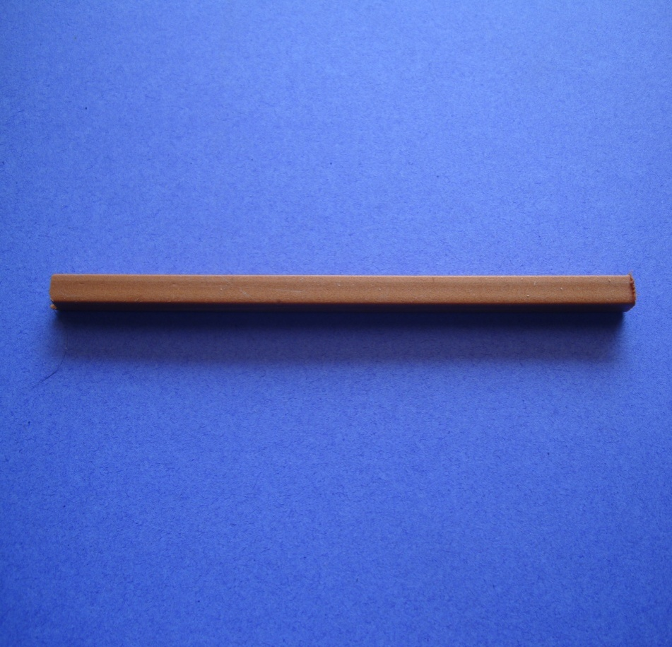

BATTERY

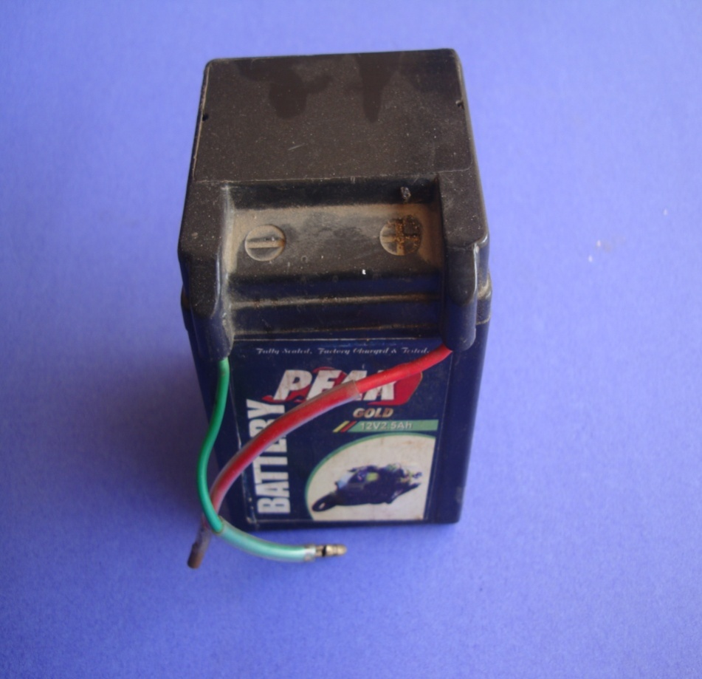

Description

Volts : 12v
2.5 amp.
Type : lead acid battery
Charging voltage : 27

PROPELLER

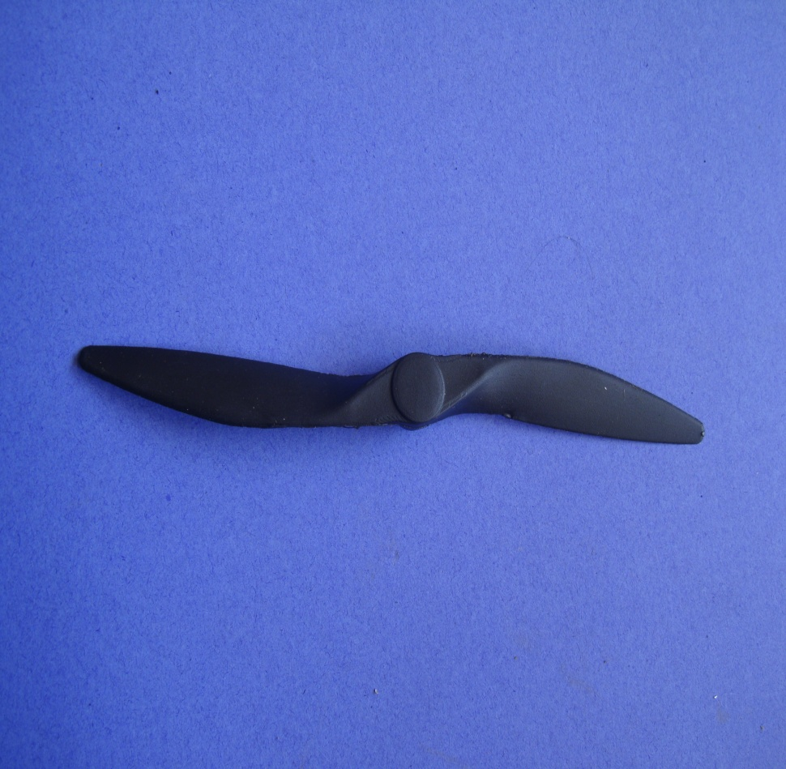

Description

Size : 17.50 cm
Material : hard plastic.

HIGH SPPED MOTOR

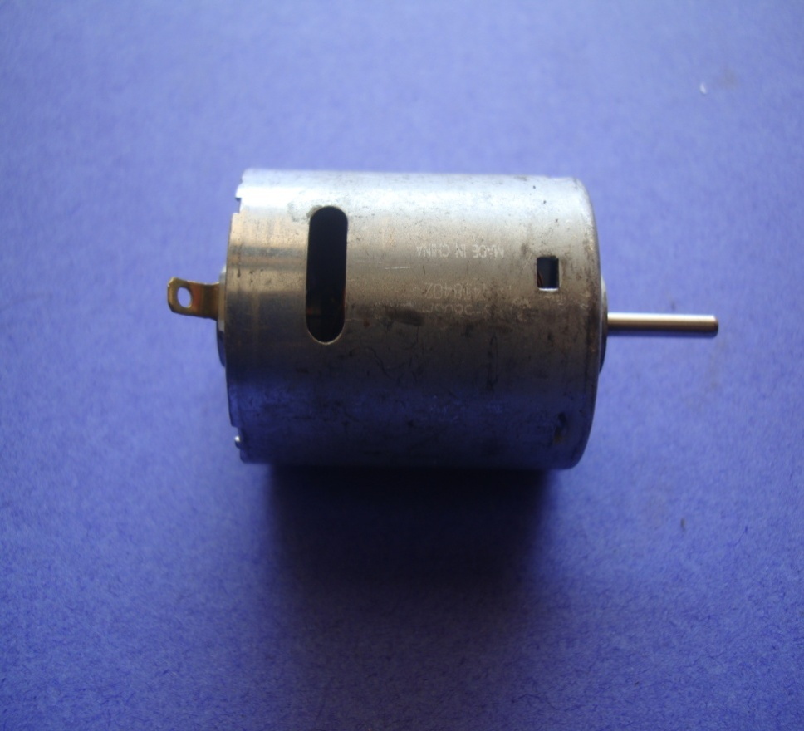

Description

Speed : 18000 rpm.
12 v.

MOTOR CONTROLLER

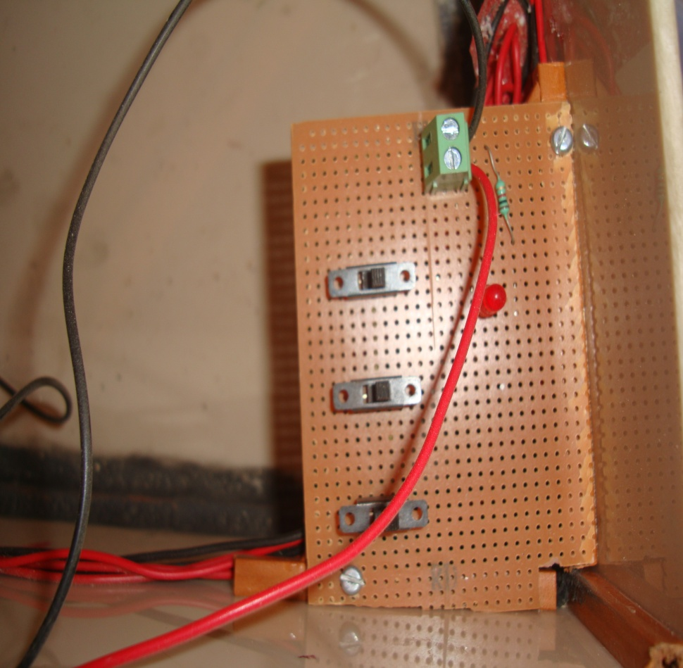

Description

4 motor & 4 switches used.

CHAPTER-3
WORKING OF OIL COLLECTOR

3.1 WORKING OF OIL COLLECTOR
3.1.1 Waste oil collection systems used:
The waste oil collection system starts from the moment when oil becomes waste, this means after they are used. In general we are talking about oil and fat used for frying. The producers/owners of waste-oil must contact the waste-oil management company and request them a collection point. These collection points are usually metal and plastic containers at the producer's place. Depending on the producer and the quantity of waste-oil it produces, the management company supplies different types of containers:
3.1.2 Municipal Clean/Green Spots:
In some municipal waste management facilities called "Clean Spots" and owned by municipalities, the waste-oil management company puts big containers (1.000 litres volume) where waste-oil from citizens and small producers is stocked. This waste is monthly collected by the company. The main municipal "Clean Spots" in the province of Burgos are located in the cities of Burgos (PuntoLimpio Norte y PuntoLimpio Sur), Briviesca, MedinadePomar, Villarcayo and Aranda de Duero. In Burgos, the City Council distributed in 2005 several specific small containers (2,5-litre bottles) between citizens in order they can collect the waste-oil at home and bring it to the Clean Spot
3.1.3 Future processing of the waste oil collected:
Once the collectors transport the oil collected to the stocking area, located in the company facilities in VillagonzaloPedernales, the waste is analysed and treated to eliminate water and big impurities and it is then delivered to the main biodiesel production plant in the North of Spain, Bionor Transformael6n. This plant is located in the neighbouring province of Alava, and uses waste-oil and pure vegetable oil as raw material for the production of biodiesel. One of its main suppliers of waste-oil is Tagus Burgos, the local waste-oil management company.
3.2 Waste oil collection systems used:
Collection in the province of Avila is realized distinguishing the following groups:
- Collection in neighbors’ communities
- Restaurants, Residences and Schools
In the first case, a few containers are delivered to the neighbours in order to they deposit in them their fried dish oil and the workmen of the company in charge of the collection are those who spill it to the containers. The periodicity depends on the type of place and the geographical location can be of weekly / fortnightly or monthly. The means which it counts on realizing this collection are: a vehicle, cars to move individually the cans that can be 25 or 501itres and a central store.
3.3 Collection Processes:
The normal process for the companies dedicated to collect the waste oil is to use mixture vehicles to carry out the routes. Fifty litres bins are shared out and replaced when they are full. These bins must be secure and they must be placed in restricted areas. After the collection, a delivery note specifying the origin and destination of the waste is given to the owner, together with a waste collection accreditation, so the owner could show them to the official administration who asks for it. The collection of these waste oils is totally free. This collection is done in certain establishments in the hotel industry, in chosen spots inside the towns, home collection, in associations and neighbor’s communities and in clean spots established bye the Administration. Collection in establishments.
The hotel industry is committed to give the waste oils they produce to a specialized manager. To make this real, Giahsa have started a campaign with information about the benefits of recycling vegetable waste oil and the possibility of convert it to biodiesel. In the leaflet the steps the companies have to follow to let a specialized manager to collect the waste oils for free using a simple phone call are detailed explained.
The normal way is to establish organized routes in which ate oils are collected once per week, per fifth teen days, per month, two months... being usual collect them once per month. Specific routes can be establishes as well, gathering those companies out of the main route. Collection in specific spots. In the province of Huelva, some agreements have been set among companies and city councils, establishing spots in the towns where the citizens can carry their waste oils.
In Nerve, for example, tour spots have been established, splitting the town in tour areas for the inhabitant's added comfort and convenience. These spots have been set in two schools, a sport facility and in the city market. The emptying of the waste oil's bottles in the bins can generate a problem if other kind of waste are dumped, like mineral oils, that can ruin the rest of the oil. Because of that, there are town like Ayamonte in which the decision has been. to let the citizens throw the waste oil in their own recipients directly in the bins, instead of emptying them in to the bins. This creates the additional work of verifying the content, so a minimum cost has been established by the company. Many city councils have developed awareness campaigns to persuade the citizens to go to those points and to spread the habit of recycling this kind of home generated waste, in environment's benefit. In order to achieve this goal, they have used leaflets, posters and related info in their websites.
3.4 Main Problems found related to the waste
management:
The first problem consists in the lack on awareness in the population, whom don' tunderstand the negative effects that the wrong management of this waste generates. So is absolutely necessary to launch awareness campaigns, because the present campaigns are only related to paper, plastics and glass. Also exists the added problem of even if the citizens are aware, they don't know what to do with to oil they don't dump. Most of them don't know about the clean spots, and this doesn't seems to be the best option, because we can assume that most of the citizen are not going to take their wastes to the spots by car. What looks like the best solution is the recycling in neighbour's associations and neighbour's communities. Anyway, more information campaigns are necessary.
In the other hand, the companies who collect waste oils have found problems in the way people store the waste oils, sometimes mixing it with other types of oils, which is very damaging for the bins. Because of that, some companies prefer that people put the oil in their bins in some kind of recipient, so they can check it later to make sure that is the right king of waste oil. But this kind of solutions creates additional costs.
Finally, the companies in this sector complain about professional intrusion in their activity. Probably they refer to some small companies that, among other activities, they collect waste oil illegally, which difficult the estimation of the real volume of waste oil collected in the province.
3.5 A NEW SEA WAY INDEPENDENT OIL SKIMMER:
The Pallas-accident in autumn 1998 in the German Bay of the North Sea has proved that the seakeeping requirements for oil recovery vessels exceed the operational limits of the German oil combating fleet. As a consequence a new Seaway independent Oil-Skimmer (SOS) is developed at the Institute of Naval Architecture and Ocean Engineering, Technical University Berlin. A skimming module based on a new working principle is applied to enable the future generation of oil recovery vessels operating in sea states with wave heights of more than 1.5 in which are rather common conditions in the North and Baltic Sea.
The surface waves are rolled out by a streamlined displacement vessel (inverse ramp) which will be integrated in a parent ship. The oil film is then guided within the boundary layer to the adjustable separation blade, and pumped off at the oil sump. This configuration has the following significant hydrodynamic advantages which extend the operational limits towards higher waves, and increase the system's efficiency especially in harsher environments:
The oil-layer is distinctly guided within the boundary layer adjacent to the hull walls straight to the duct where it is pumped off. Channels in the outer hull walls could amplify this guiding effect, resulting in high concentrated oil flow at the separation blade.
The actual skimming device - the separation blade - is located at the rear part underneath the vessel, avoiding a free surface and thus all adverse mixing processes due to breaking waves.
The oil skimmer is very robust and without movable components.
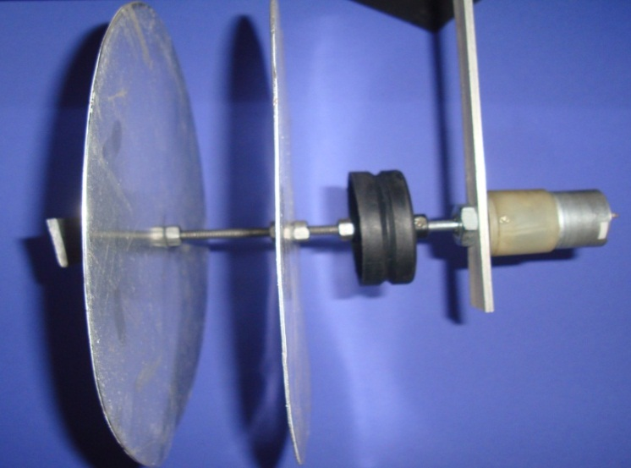

First model towing tests in an oil tank revealed, that during operation the oil layer is well collected within the boundary layer underneath the hull before it is efficiently diverted inside the vessel by the adjustable separation blade. Experiments in calm waters and in waves as well as at low and high speeds proved that this new oil skimming method works robust and reliable for a wide spectrum of operating conditions. In experimental and numerical investigations global and local flow phenomena are analysed. The analysis starts with the optimisation of 2D skimmer geometries. Not only the flow-field near the separation blade is highly susceptible to unfavourable streamlining, but the pressure field around the whole vessel is decisive for an efficient skimming process. It presents the grid structure for MANSE based CFD simulations and results showing the flow-field at the inlet area close to the separation blade. Due to the pressure loss behind the bow-component of the skimmer a stationary vortex is generated in the moon pool area with low velocities at the separation blade. This vortex transports the light oil particles to regions at the moon pool surface, from where the oil is pumped to the carrier. It illustrates that a sharp trailing edge at the bow segment close to the separation blade generates a strong stationary vortex in the dead water stream shadow of the incoming flow.

Application
- In Bombay high
- Used in navy

Advantages
- collect waste oil from sea water.
- Controll pollution.
- Reuse of waste oil.
- Cost is low
- Efficiency high
- Required less man power.
- No need of any chemical material for this process

Disadvantages
- Oil spill is not possible in routine life so we required space to store this system.

- Operating cost high.

CHAPTER-4
CONCLUSIONS
The limitations of existing oil recovery systems in severe sea states are a challenge for the development of a new generation of robust oil recovery vessels. This paper gives an overview of the German oil recovery fleet with its different devices for oil recovery including their advantages and limitations. Future developments are required for higher waves and smaller draft. These designs should be optimized for transit, operation and survival conditions. Relevant requirements lead to the following design criteria:
· High transit speed
· Wide intake area for an extensive skimming range
· Low hydrodynamic resistance of the system
· docking device
· Sea-keeping ability
· Ability to operate in shallow waters
In the scope of a research project funded by the German Federal Ministry of Education, Research and Technology a Seaway independent Oil Skimmer (SOS) is developed, applying a new skimming method by avoiding high waves at the skimming location. First experimental results and numerical simulations are promising, indicating an efficient oil recovery process for rough sea states. Additional investigations are under way. When the model scale tests are confirmed, fullscale tests with existing oil skimming systems are envisaged as well as the development of a new carrier.

REFERENCE

- www.google.com
- www.wikipedia.com

